Neural Network Assignment -2
Name = Hema Rajput
Roll no = 24UADS1062

Q2. WAP to implement a multi-layer perceptron (MLP) network with one hidden layer using numpy in Python. Demonstrate that it can learn the XOR Boolean function.

%matplotlib inline
import numpy as np
import matplotlib.pyplot as plt
from matplotlib.animation import FuncAnimation
from mpl_toolkits.mplot3d import Axes3D
from IPython.display import HTML, display

# ---------------XOR Data--------------
inputs = np.array([
[0,0],
[0,1],
[1,0],
[1,1]
])

targets = np.array([[0],[1],[1],[0]])
np.random.seed(42)

# -----------------Activation Function------------------
def activation(x):
val = 1/(1+np.exp(-x))
return val

def activation_deriv(a):
return a*(1-a)

input_dim = 2
hidden_dim = 5
output_dim = 1

learning_rate = 0.1
num_epochs = 25

weights_input_hidden = np.random.randn(input_dim, hidden_dim)
bias_hidden = np.zeros((1,hidden_dim))

weights_hidden_output = np.random.randn(hidden_dim, output_dim)
bias_output = np.zeros((1,output_dim))

loss_history = []
epoch_predictions = []
weights_over_time = []

# -----------------Training function----------------
for epoch in range(num_epochs):
print(f"\n EPOCH {epoch+1}")

# ------------------Forward-------------------
hidden_input = np.dot(inputs, weights_input_hidden) + bias_hidden
print("Hidden Input:\n", hidden_input)

hidden_output = activation(hidden_input)
print("Hidden Output:\n", hidden_output)

output_input = np.dot(hidden_output, weights_hidden_output) + bias_output
print("Output Input:\n", output_input)

predictions = activation(output_input)
print("Predicted Output:\n", predictions)
epoch_predictions.append(predictions.copy())

# ----------------------Loss-------------------
loss = np.mean((targets - predictions)**2)
loss_history.append(loss)
print("LOSS:", loss)

# -------------------Accuracy-------------------
accuracy = np.mean((predictions > 0.5) == targets)
print("ACCURACY:", accuracy)

# ------------------Backprop-------------------
output_error = (predictions - targets) * activation_deriv(predictions)

grad_weights_hidden_output = np.dot(hidden_output.T, output_error)
grad_bias_output = np.sum(output_error, axis=0, keepdims=True)

hidden_error = np.dot(output_error, weights_hidden_output.T)
hidden_grad = hidden_error * activation_deriv(hidden_output)

grad_weights_input_hidden = np.dot(inputs.T, hidden_grad)
grad_bias_hidden = np.sum(hidden_grad, axis=0, keepdims=True)

# --------------------Update------------------
weights_input_hidden -= learning_rate * grad_weights_input_hidden
bias_hidden -= learning_rate * grad_bias_hidden
weights_hidden_output -= learning_rate * grad_weights_hidden_output
bias_output -= learning_rate * grad_bias_output

print("Updated Weights Input-Hidden:\n", weights_input_hidden)
print("Updated Weights Hidden-Output:\n", weights_hidden_output)

# --------------------Save weights for animation-----------------------
weights_over_time.append((weights_input_hidden.copy(), bias_hidden.copy(), weights_hidden_output.copy(), bias_output.copy()))

# -----------------------Graph for each epochs------------------------
for i, pred in enumerate(epoch_predictions):
plt.figure(figsize=(5,4))

plt.scatter(range(4), targets, label="True", s=120, color='orange')
plt.scatter(range(4), pred, label="Predicted", s=120, color='green')

plt.title(f"Epoch {i+1}")
plt.ylim(-0.2,1.2)
plt.legend()
plt.show()

# ---------------Loss Graph------------------
plt.figure(figsize=(7,5))
plt.plot(loss_history, marker='o', color='green')
plt.title("Loss vs Epochs")
plt.xlabel("Epoch")
plt.ylabel("Loss")
plt.show()

# ------------------Grid function for surface-----------------------
def compute_surface(w_ih, b_h, w_ho, b_o):
grid_x, grid_y = np.meshgrid(
np.linspace(0,1,30),
np.linspace(0,1,30)
)

grid = np.c_[grid_x.ravel(), grid_y.ravel()]

hidden = activation(np.dot(grid, w_ih) + b_h)
preds = activation(np.dot(hidden, w_ho) + b_o)

return grid_x, grid_y, preds.reshape(grid_x.shape)

# --------------------3D animation------------------------
fig = plt.figure(figsize=(9,7))
ax = fig.add_subplot(111, projection='3d')

def update_plot(i):
ax.clear()
w_ih, b_h, w_ho, b_o = weights_over_time[i]
gx, gy, gz = compute_surface(w_ih, b_h, w_ho, b_o)

ax.plot_surface(gx, gy, gz, alpha=0.7, color='cyan')
ax.scatter(inputs[:,0], inputs[:,1], targets[:,0], s=120, color='magenta')

ax.set_title(f"Learning XOR — Epoch {i+1}")
ax.set_zlim(0,1)

ax.set_xlabel("Input 1")
ax.set_ylabel("Input 2")
ax.set_zlabel("Output")

ani = FuncAnimation(
fig,
update_plot,
frames=len(weights_over_time),
interval=250
)
plt.close(fig)
display(HTML(ani.to_jshtml()))

# --------------------Final 3D surface------------------
fig = plt.figure(figsize=(8,6))
ax = fig.add_subplot(111, projection='3d')

gx, gy, gz = compute_surface(weights_input_hidden, bias_hidden, weights_hidden_output, bias_output)

ax.plot_surface(gx, gy, gz, alpha=0.8, color='pink')
ax.scatter(inputs[:,0], inputs[:,1], targets[:,0], s=120, color='purple')

ax.set_title("Final Learned XOR Surface")
ax.set_zlim(0,1)
plt.show()

Output
EPOCH 1
Hidden Input:
[[ 0. 0. 0. 0. 0. ]
[-0.23413696 1.57921282 0.76743473 -0.46947439 0.54256004]
[ 0.49671415 -0.1382643 0.64768854 1.52302986 -0.23415337]
[ 0.2625772 1.44094851 1.41512327 1.05355547 0.30840667]]
Hidden Output:
[[0.5 0.5 0.5 0.5 0.5 ]
[0.44173171 0.829093 0.68296571 0.38474066 0.63240775]
[0.62168683 0.46548889 0.65648939 0.82098421 0.44172766]
[0.56526972 0.80860149 0.80457276 0.74145706 0.5764963 ]]
Output Input:
[[-2.16269163]
[-2.25255573]
[-2.67876382]
[-2.85689341]]
Predicted Output:
[[0.10315118]
[0.09512924]
[0.06423814]
[0.05432608]]
LOSS: 0.427008207463978
ACCURACY: 0.5
Updated Weights Input-Hidden:
[[ 0.49613285 -0.138896 0.64798485 1.52155051 -0.23642856]
[-0.23499532 1.57871891 0.76783219 -0.47289972 0.53955424]]
Updated Weights Hidden-Output:
[[-0.4571149 ]
[-0.4573563 ]
[ 0.25027303]
[-1.90634948]
[-1.71814525]]

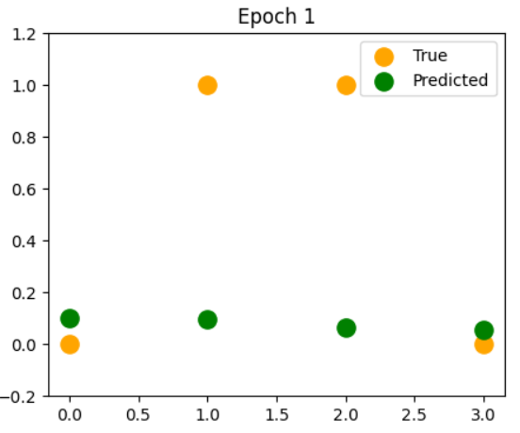

EPOCH 2
Hidden Input:
[[-1.36088995e-03 -1.03461485e-03 6.46662650e-04 -4.55061009e-03
-4.98701923e-03]
[-2.36356209e-01 1.57768429e+00 7.68478848e-01 -4.77450333e-01
5.34567224e-01]
[ 4.94771964e-01 -1.39930613e-01 6.48631512e-01 1.51699990e+00
-2.41415580e-01]
[ 2.59776645e-01 1.43878829e+00 1.41646370e+00 1.04410017e+00
2.98138663e-01]]
Hidden Output:
[[0.49965978 0.49974135 0.50016167 0.49886235 0.49875325]
[0.4411845 0.82887631 0.68319175 0.38285437 0.63054771]
[0.62122994 0.46507432 0.65670201 0.82009628 0.43993753]
[0.56458139 0.80826694 0.80478344 0.73964036 0.57398743]]
Output Input:
[[-2.12754056]
[-2.21082538]
[-2.63940927]
[-2.810355 ]]
Predicted Output:
[[0.1064487 ]
[0.09878257]
[0.06664477]
[0.05676717]]
LOSS: 0.4244746690999502
ACCURACY: 0.5
Updated Weights Input-Hidden:
[[ 0.49554254 -0.13953504 0.64830048 1.52002916 -0.23875866]
[-0.23586534 1.57821998 0.76825484 -0.47640193 0.53647068]]
Updated Weights Hidden-Output:
[[-0.45064606]
[-0.44875774]
[ 0.25881594]
[-1.89924646]
[-1.71121162]]

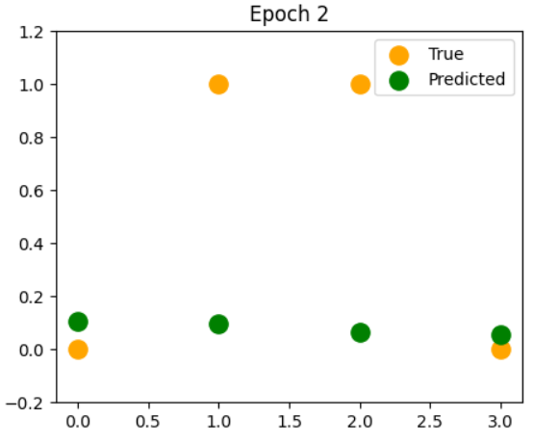
EPOCH 3
Hidden Input:
[[-2.73967483e-03 -2.07835719e-03 1.33354015e-03 -9.20319886e-03
-1.00934754e-02]
[-2.38605015e-01 1.57614163e+00 7.69588377e-01 -4.85605129e-01
5.26377209e-01]
[ 4.92802863e-01 -1.41613399e-01 6.49634015e-01 1.51082596e+00
-2.48852139e-01]
[ 2.56937523e-01 1.43660658e+00 1.41788885e+00 1.03442403e+00
2.87618545e-01]]
Hidden Output:
[[0.49931508 0.49948041 0.50033338 0.49769922 0.49747665]
[0.44063015 0.82865738 0.68343184 0.38092943 0.62863776]
[0.62076649 0.4646557 0.65692798 0.81918358 0.43810605]
[0.56388332 0.80792861 0.80500724 0.73777269 0.57141301]]
Output Input:
[[-2.09151402]
[-2.16806961]
[-2.59907095]
[-2.76265495]]
Predicted Output:
[[0.10992435]
[0.10265472]
[0.06919824]
[0.05937591]]
LOSS: 0.42180733497108186
ACCURACY: 0.5
Updated Weights Input-Hidden:
[[ 0.49494325 -0.14018119 0.64863671 1.51846442 -0.24114519]
[-0.23674673 1.57771639 0.76870423 -0.47998232 0.53330748]]
Updated Weights Hidden-Output:
[[-0.44400613]
[-0.43992739]
[ 0.26759862]
[-1.89196638]
[-1.70411323]]

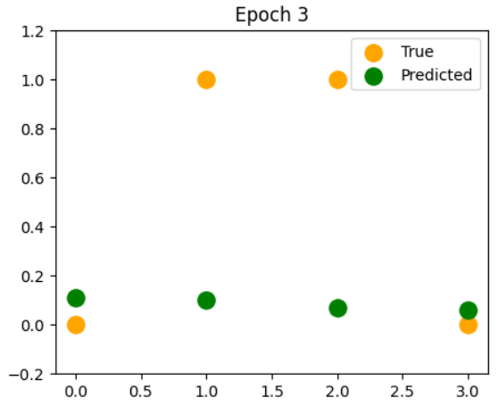
EPOCH 4
Hidden Input:
[[-0.00413593 -0.00313053 0.00206305 -0.01395952 -0.01532208]
[-0.24088265 1.57458586 0.77076727 -0.49394184 0.5179854 ]
[ 0.49080733 -0.14331173 0.65069976 1.5045049 -0.25646727]
[ 0.2540606 1.43440466 1.41940398 1.02452258 0.27684022]]
Hidden Output:
[[0.49896602 0.49921737 0.50051576 0.49651018 0.49616956]
[0.44006885 0.82843638 0.68368685 0.37896541 0.62667657]
[0.6202966 0.46423326 0.65716813 0.8182454 0.43623233]
[0.5631757 0.80758669 0.80524496 0.73585261 0.56877139]]
Output Input:
[[-2.0545884 ]
[-2.1242618 ]
[-2.55772191]
[-2.71376247]]
Predicted Output:
[[0.11358957]
[0.10676097]
[0.07190943]
[0.06216613]]
LOSS: 0.4189988220438994
ACCURACY: 0.5
Updated Weights Input-Hidden:
[[ 0.49433511 -0.14083415 0.64899493 1.5168549 -0.24358957]
[-0.23763909 1.57720855 0.76918197 -0.48364198 0.53006291]]
Updated Weights Hidden-Output:
[[-0.43719024]
[-0.43085883]
[ 0.27662857]
[-1.88450468]
[-1.6968467 ]]

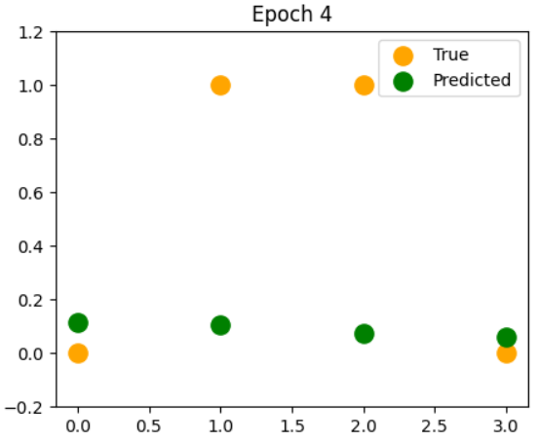

EPOCH 5
Hidden Input:
[[-0.00554907 -0.00419032 0.00283771 -0.01882106 -0.0206753 ]
[-0.24318816 1.57301823 0.77201968 -0.50246303 0.50938761]
[ 0.48878603 -0.14502447 0.65183263 1.49803384 -0.26426487]
[ 0.25114695 1.43218408 1.4210146 1.01439187 0.26579804]]
Hidden Output:
[[0.49861274 0.49895242 0.50070943 0.49529487 0.49483136]
[0.43950083 0.82821346 0.68395763 0.37696202 0.62466291]
[0.61982041 0.46380729 0.65742332 0.81728105 0.4343156 ]
[0.56245878 0.80724139 0.80549743 0.73387876 0.56606104]]
Output Input:
[[-2.01674131]
[-2.07937691]
[-2.51533647]
[-2.66364844]]
Predicted Output:
[[0.11745637]
[0.11111749]
[0.07479001]
[0.06515276]]
LOSS: 0.4160416306569554
ACCURACY: 0.5
Updated Weights Input-Hidden:
[[ 0.49371825 -0.14149354 0.64937659 1.51519928 -0.24609316]
[-0.23854192 1.57669697 0.76968975 -0.48738173 0.52673546]]
Updated Weights Hidden-Output:
[[-0.43019375]
[-0.421546 ]
[ 0.28591301]
[-1.87685707]
[-1.68940902]]

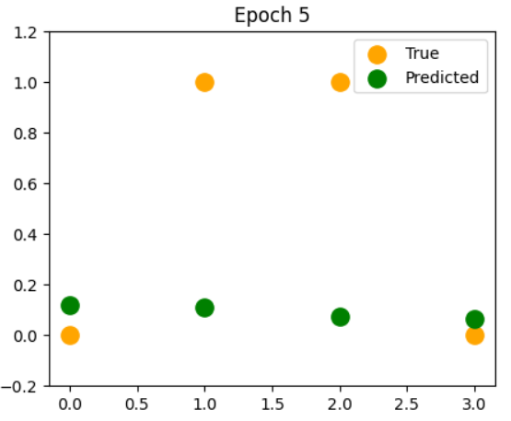

EPOCH 6
Hidden Input:
[[-0.00697839 -0.00525675 0.00366015 -0.02378891 -0.0261553 ]
[-0.24552031 1.57144022 0.7733499 -0.51117063 0.50058016]
[ 0.48673986 -0.14675029 0.65303674 1.49141037 -0.27224845]
[ 0.24819794 1.42994668 1.42272649 1.00402864 0.25448701]]
Hidden Output:
[[0.49825541 0.49868582 0.50091504 0.49405305 0.49346155]
[0.43892641 0.82798883 0.6842451 0.37491914 0.62259566]
[0.61933813 0.46337813 0.65769446 0.81628987 0.43235519]
[0.5617329 0.80689301 0.80576549 0.73184992 0.5632806 ]]
Output Input:
[[-1.97795204]
[-2.033392 ]
[-2.47189078]
[-2.61228611]]
Predicted Output:
[[0.12153732]
[0.11574131]
[0.07785239]
[0.06835188]]
LOSS: 0.4129282366248612
ACCURACY: 0.5
Updated Weights Input-Hidden:
[[ 0.49309291 -0.14215889 0.64978325 1.5134963 -0.24865716]
[-0.23945461 1.57618221 0.77022931 -0.49120204 0.52332386]]
Updated Weights Hidden-Output:
[[-0.42301237]
[-0.41198336]
[ 0.29545878]
[-1.86901967]
[-1.68179776]]

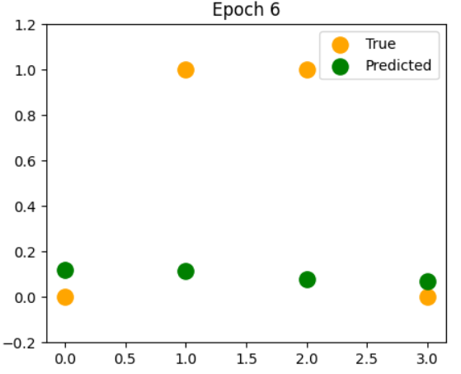

EPOCH 7
Hidden Input:
[[-0.00842296 -0.00632869 0.00453309 -0.02886375 -0.03176383]
[-0.24787757 1.56985352 0.77476241 -0.52006579 0.49156003]
[ 0.48466996 -0.14848758 0.65431634 1.48463255 -0.28042098]
[ 0.24521534 1.42769463 1.42454566 0.99343051 0.24290288]]
Hidden Output:
[[0.49789427 0.49841783 0.50113327 0.49278456 0.49205971]
[0.43834597 0.82776273 0.6845502 0.37283685 0.62047387]
[0.61885001 0.46294616 0.65798248 0.81527128 0.43035057]
[0.56099849 0.80654186 0.80605004 0.72976498 0.56042889]]
Output Input:
[[-1.93820213]
[-1.98628694]
[-2.42736341]
[-2.55965183]]
Predicted Output:
[[0.1258455 ]
[0.12065024]
[0.08110976]
[0.07178074]]
LOSS: 0.40965121069167876
ACCURACY: 0.5
Updated Weights Input-Hidden:
[[ 0.4924594 -0.14282965 0.65021652 1.51174483 -0.25128261]
[-0.24037639 1.57566498 0.77080245 -0.49510299 0.51982721]]
Updated Weights Hidden-Output:
[[-0.41564223]
[-0.4021661 ]
[ 0.30527216]
[-1.86098913]
[-1.67401109]]

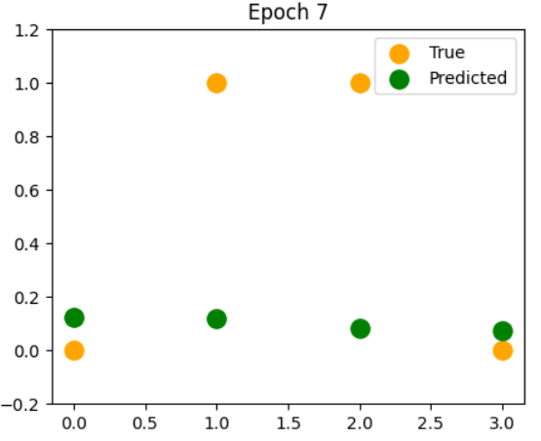

EPOCH 8
Hidden Input:
[[-0.00988167 -0.00740484 0.00545934 -0.03404571 -0.03750216]
[-0.25025807 1.56826014 0.77626179 -0.52914869 0.48232506]
[ 0.48257773 -0.15023449 0.65567586 1.47769913 -0.28878477]
[ 0.24220134 1.42543049 1.42647831 0.98259614 0.23104244]]
Hidden Output:
[[0.4975296 0.4981488 0.50136483 0.4914894 0.49062556]
[0.43775998 0.82753544 0.68487389 0.37071546 0.61829675]
[0.61835638 0.46251186 0.65828836 0.8142248 0.4283014 ]
[0.56025606 0.80618833 0.806352 0.72762304 0.55750503]]
Output Input:
[[-1.89747605]
[-1.93804522]
[-2.38173615]
[-2.50572591]]
Predicted Output:
[[0.1303944 ]
[0.12586277]
[0.08457605]
[0.07545775]]
LOSS: 0.4062033701609313
ACCURACY: 0.5
Updated Weights Input-Hidden:
[[ 0.49181811 -0.14350515 0.65067812 1.50994387 -0.25397036]
[-0.24130635 1.57514605 0.77141099 -0.49908413 0.51624501]]
Updated Weights Hidden-Output:
[[-0.4080801 ]
[-0.39209028]
[ 0.31535867]
[-1.85276275]
[-1.66604803]]

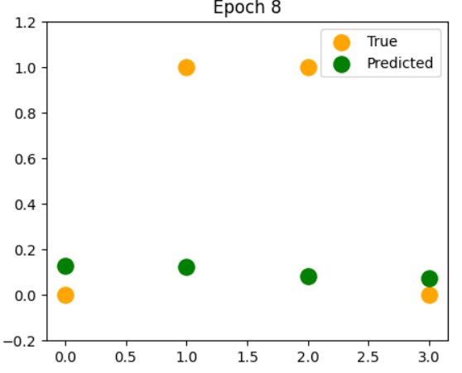

EPOCH 9
Hidden Input:
[[-0.01135319 -0.0084837 0.00644173 -0.03933427 -0.04337093]
[-0.25265954 1.56666235 0.77785273 -0.5384184 0.47287408]
[ 0.48046492 -0.15198885 0.65711985 1.47060961 -0.29734129]
[ 0.23915857 1.4231572 1.42853085 0.97152547 0.21890372]]
Hidden Output:
[[0.49716173 0.49787909 0.50161043 0.4901677 0.48915897]
[0.437169 0.82730728 0.68521714 0.36855558 0.61606379]
[0.61785765 0.46207577 0.65861311 0.81315003 0.42620756]
[0.55950628 0.80583289 0.8066723 0.72542345 0.55450844]]
Output Input:
[[-1.85576193]
[-1.88865483]
[-2.33499479]
[-2.45049374]]
Predicted Output:
[[0.1351978 ]
[0.13139792]
[0.08826588]
[0.07940245]]
LOSS: 0.4025779676813555
ACCURACY: 0.5
Updated Weights Input-Hidden:
[[ 0.49116953 -0.14418461 0.65116983 1.50809263 -0.25672094]
[-0.24224339 1.57462632 0.77205678 -0.50314446 0.51257726]]
Updated Weights Hidden-Output:
[[-0.40032348]
[-0.3817531 ]
[ 0.32572288]
[-1.84433869]
[-1.65790854]]

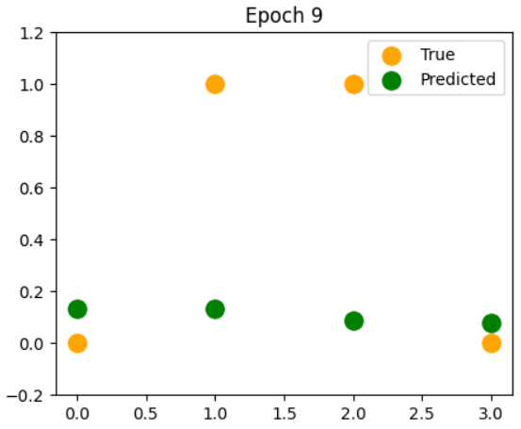

EPOCH 10
Hidden Input:
[[-0.01283592 -0.00956356 0.00748315 -0.04472815 -0.04937007]
[-0.2550793 1.56506276 0.77953993 -0.54787261 0.46320719]
[ 0.47833362 -0.15374817 0.65865297 1.46336448 -0.30609101]
[ 0.23609023 1.42087815 1.43070975 0.96022002 0.20648625]]
Hidden Output:
[[0.49679106 0.49760913 0.50187078 0.48881983 0.48765999]
[0.43657371 0.82707863 0.68558095 0.36635812 0.61377473]
[0.61735431 0.4616385 0.65895773 0.81204672 0.42406917]
[0.55874992 0.80547605 0.80701188 0.72316585 0.55143893]]
Output Input:
[[-1.8130525 ]
[-1.83810933]
[-2.28713018]
[-2.39394689]]
Predicted Output:
[[0.14026961]
[0.13727505]
[0.09219446]
[0.08363544]]
LOSS: 0.39876892199282016
ACCURACY: 0.5
Updated Weights Input-Hidden:
[[ 0.49051429 -0.14486713 0.65169348 1.50619054 -0.25953459]
[-0.24318622 1.57410681 0.77274165 -0.50728227 0.50882455]]
Updated Weights Hidden-Output:
[[-0.39237082]
[-0.37115317]
[ 0.33636809]
[-1.8357161 ]
[-1.64959378]]
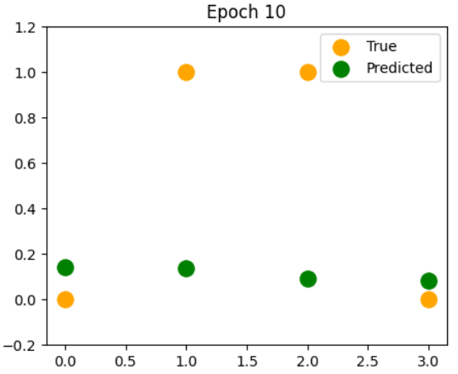
EPOCH 11
Hidden Input:
[[-0.01432798 -0.01064248 0.00858644 -0.05022515 -0.05549859]
[-0.2575142 1.56346433 0.78132809 -0.55750742 0.45332597]
[ 0.47618631 -0.15550961 0.66027991 1.45596539 -0.31503317]
[ 0.23300009 1.4185972 1.43302156 0.94868312 0.19379138]]
Hidden Output:
[[0.49641807 0.4973394 0.5021466 0.48744635 0.48612891]
[0.43597487 0.8268499 0.68596628 0.36412439 0.61142972]
[0.61684692 0.46120076 0.65932326 0.81091482 0.42188668]
[0.55798792 0.80511841 0.80737167 0.72085027 0.54829679]]
Output Input:
[[-1.76934608]
[-1.78640904]
[-2.23813933]
[-2.33608453]]
Predicted Output:
[[0.14562367]
[0.14351355]
[0.09637746]
[0.08817822]]
LOSS: 0.3947710947694215
ACCURACY: 0.5
Updated Weights Input-Hidden:
[[ 0.48985311 -0.14555164 0.65225096 1.50423736 -0.26241111]
[-0.24413337 1.57358868 0.77346739 -0.51149506 0.50498823]]
Updated Weights Hidden-Output:
[[-0.38422172]
[-0.36029079]
[ 0.34729612]
[-1.8268954 ]
[-1.64110627]]

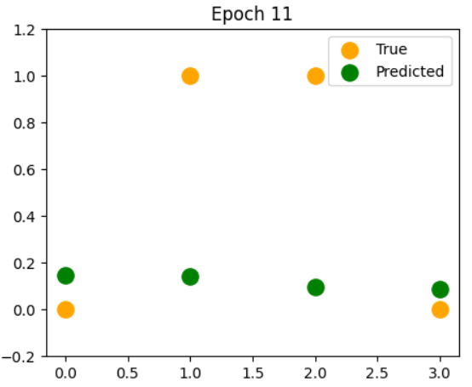

EPOCH 12
Hidden Input:
[[-0.0158272 -0.01171831 0.00975439 -0.05582204 -0.06175448]
[-0.25996057 1.56187037 0.78322179 -0.56731709 0.44323375]
[ 0.47402592 -0.15726995 0.66200535 1.44841532 -0.32416559]
[ 0.22989255 1.41631873 1.43547275 0.93692027 0.18082264]]
Hidden Output:
[[0.49604328 0.49707046 0.50243858 0.48604811 0.48456628]
[0.4353734 0.82662158 0.68637407 0.36185612 0.6090293 ]
[0.61633619 0.46076335 0.65971072 0.80975443 0.4196609 ]
[0.55722134 0.80476066 0.8077526 0.71847715 0.54508289]]
Output Input:
[[-1.72464767]
[-1.73356239]
[-2.18802665]
[-2.27691489]]
Predicted Output:
[[0.15127348]
[0.15013248]
[0.10083086]
[0.09305299]]
LOSS: 0.390580616332096
ACCURACY: 0.5
Updated Weights Input-Hidden:
[[ 0.48918688 -0.14623696 0.6528442 1.50223321 -0.26534985]
[-0.24508312 1.57307321 0.77423572 -0.51577938 0.50107044]]
Updated Weights Hidden-Output:
[[-0.37587716]
[-0.34916831]
[ 0.35850688]
[-1.81787847]
[-1.63245016]]

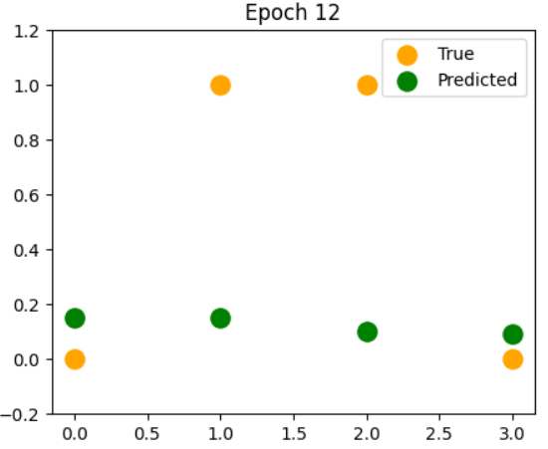

EPOCH 13
Hidden Input:
[[-0.01733107 -0.01278862 0.01098969 -0.06151435 -0.06813451]
[-0.26241419 1.56028459 0.78522541 -0.57729373 0.43293593]
[ 0.47185581 -0.15902558 0.66383389 1.44071886 -0.33348436]
[ 0.22677269 1.41404763 1.43806961 0.92493948 0.16758607]]
Hidden Output:
[[0.49566734 0.49680289 0.50274739 0.48462626 0.48297296]
[0.43477034 0.82639419 0.68680521 0.35955554 0.60657452]
[0.61582291 0.46032718 0.66012109 0.80856595 0.41739307]
[0.55645146 0.80440358 0.80815554 0.71604749 0.54179874]]
Output Input:
[[-1.67897028]
[-1.67958735]
[-2.13680537]
[-2.21645695]]
Predicted Output:
[[0.15723187]
[0.15715012]
[0.10557066]
[0.09828235]]
LOSS: 0.38619526070662996
ACCURACY: 0.5
Updated Weights Input-Hidden:
[[ 0.48851664 -0.14692171 0.65347512 1.50017867 -0.26834958]
[-0.24603352 1.57256181 0.77504822 -0.52013079 0.4970743 ]]
Updated Weights Hidden-Output:
[[-0.36733977]
[-0.33779048]
[ 0.3699981 ]
[-1.80866893]
[-1.62363144]]
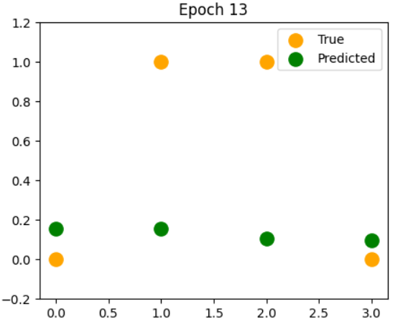
EPOCH 14
Hidden Input:
[[-0.01883675 -0.01385075 0.01229479 -0.06729625 -0.07463405]
[-0.26487028 1.55871106 0.78734301 -0.58742704 0.42244025]
[ 0.46967989 -0.16077246 0.66576991 1.43288242 -0.34298363]
[ 0.22364636 1.41178936 1.44081813 0.91275163 0.15409067]]
Hidden Output:
[[0.49529095 0.49653737 0.50307366 0.48318228 0.48135014]
[0.43416687 0.82616832 0.68726054 0.35722543 0.60406703]
[0.61530799 0.45989324 0.66055532 0.80735003 0.4150849 ]
[0.5556797 0.80404802 0.80858131 0.7135629 0.53844662]]
Output Input:
[[-1.63233617]
[-1.62451302]
[-2.08449905]
[-2.15474219]]
Predicted Output:
[[0.16351058]
[0.16458341]
[0.11061259]
[0.10388891]]
LOSS: 0.3816148670318186
ACCURACY: 0.5
Updated Weights Input-Hidden:
[[ 0.48784358 -0.14760436 0.65414561 1.49807484 -0.2714084 ]
[-0.24698239 1.57205605 0.77590631 -0.52454362 0.49300402]]
Updated Weights Hidden-Output:
[[-0.35861409]
[-0.32616484]
[ 0.38176486]
[-1.79927238]
[-1.6146582 ]]

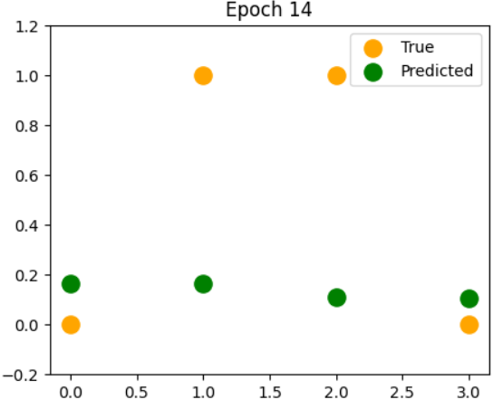

EPOCH 15
Hidden Input:
[[-0.02034104 -0.01490179 0.0136719 -0.07316036 -0.08124689]
[-0.26732343 1.55715427 0.7895782 -0.59770399 0.41175713]
[ 0.46750253 -0.16250615 0.6678175 1.42491447 -0.3526553 ]
[ 0.22052014 1.40954991 1.44372381 0.90037085 0.14034873]]
Hidden Output:
[[0.49491491 0.49627462 0.50341792 0.48171806 0.47969944]
[0.43356431 0.82594463 0.68774076 0.35486916 0.60150913]
[0.61479247 0.45946263 0.66101429 0.80610769 0.41273867]
[0.55490771 0.80369494 0.80903064 0.71102571 0.5350297 ]]
Output Input:
[[-1.58477836]
[-1.56838124]
[-2.03114315]
[-2.09181649]]
Predicted Output:
[[0.17011981]
[0.17244728]
[0.11597167]
[0.10989476]]
LOSS: 0.37684179946636176
ACCURACY: 0.5
Updated Weights Input-Hidden:
[[ 0.48716906 -0.14828322 0.65485751 1.49592345 -0.27452369]
[-0.24792729 1.57155761 0.77681114 -0.52901097 0.48886506]]
Updated Weights Hidden-Output:
[[-0.34970686]
[-0.31430213]
[ 0.39379922]
[-1.78969673]
[-1.60554091]]

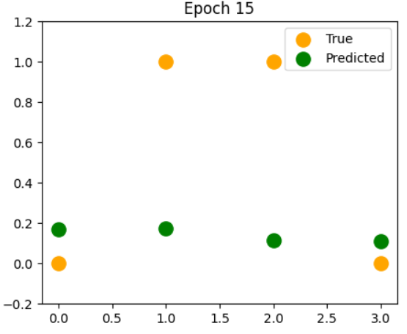

EPOCH 16
Hidden Input:
[[-0.02184036 -0.01593857 0.01512283 -0.0790976 -0.08796505]
[-0.26976765 1.55561904 0.79193397 -0.60810857 0.40090001]
[ 0.4653287 -0.16422179 0.66998033 1.41682585 -0.36248874]
[ 0.21740142 1.40733582 1.44679148 0.88781488 0.12637632]]
Hidden Output:
[[0.49454013 0.49601544 0.50378063 0.4802359 0.47802291]
[0.43296414 0.82572381 0.68824644 0.35249078 0.59890388]
[0.61427753 0.45903657 0.66149876 0.80484033 0.41035725]
[0.5541373 0.80334539 0.80950415 0.70843904 0.5315521 ]]
Output Input:
[[-1.53634202]
[-1.51124834]
[-1.97678669]
[-2.02774204]]
Predicted Output:
[[0.17706767]
[0.18075386]
[0.1216618 ]
[0.11632082]]
LOSS: 0.3718814313896663
ACCURACY: 0.5
Updated Weights Input-Hidden:
[[ 0.48649466 -0.1489564 0.65561254 1.49372695 -0.27769196]
[-0.24886554 1.57106828 0.77776359 -0.53352449 0.48466417]]
Updated Weights Hidden-Output:
[[-0.3406273 ]
[-0.30221664]
[ 0.40608979]
[-1.77995241]
[-1.59629261]]
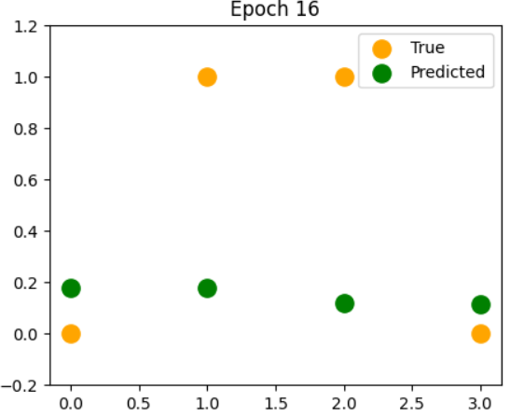
EPOCH 17
Hidden Input:
[[-0.02333078 -0.01695774 0.01664891 -0.08509702 -0.09477858]
[-0.27219632 1.55411054 0.7944125 -0.61862151 0.38988559]
[ 0.46316387 -0.16591414 0.67226145 1.40862993 -0.37247055]
[ 0.21429834 1.40515414 1.45002504 0.87510544 0.11219362]]
Hidden Output:
[[0.49416757 0.49576067 0.50416213 0.47873857 0.47632308]
[0.43236798 0.82550663 0.68877799 0.35009503 0.59625516]
[0.61376447 0.45861635 0.66200935 0.80354976 0.40794419]
[0.55337049 0.8030005 0.81000229 0.70580692 0.52801902]]
Output Input:
[[-1.4870859 ]
[-1.45318668]
[-1.92149382]
[-1.96259917]]
Predicted Output:
[[0.18435952]
[0.18951162]
[0.12769508]
[0.12318603]]
LOSS: 0.366742631919558
ACCURACY: 0.5
Updated Weights Input-Hidden:
[[ 0.48582208 -0.14962189 0.65641226 1.49148858 -0.28090881]
[-0.24979423 1.57058995 0.77876411 -0.53807439 0.4804096 ]]
Updated Weights Hidden-Output:
[[-0.3313874 ]
[-0.28992667]
[ 0.41862131]
[-1.77005271]
[-1.58692915]]

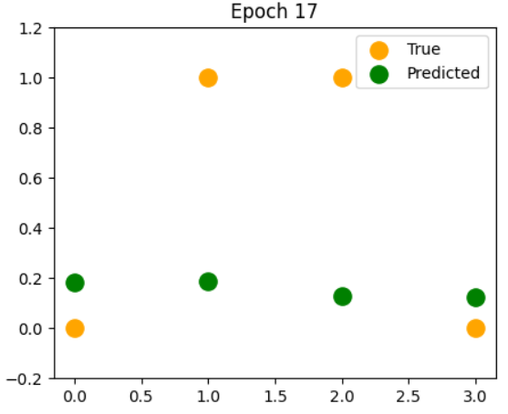
EPOCH 18
Hidden Input:
[[-0.02480803 -0.01795572 0.01825089 -0.09114567 -0.10167547]
[-0.27460226 1.55263423 0.79701501 -0.62922006 0.37873413]
[ 0.46101405 -0.1675776 0.67466316 1.40034291 -0.38258428]
[ 0.21121982 1.40301235 1.45342727 0.86226852 0.09782532]]
Hidden Output:
[[0.49379831 0.49551119 0.5045626 0.47722934 0.47460301]
[0.4317776 0.82529387 0.6893356 0.34768741 0.59356775]
[0.61325471 0.45820337 0.66254653 0.8022383 0.40550375]
[0.55260951 0.80266147 0.81052533 0.7031344 0.52443684]]
Output Input:
[[-1.43708365]
[-1.39428621]
[-1.86534537]
[-1.89648809]]
Predicted Output:
[[0.19199737]
[0.19872437]
[0.13408122]
[0.13050647]]
LOSS: 0.361438223962787
ACCURACY: 0.5
Updated Weights Input-Hidden:
[[ 0.48515323 -0.15027749 0.65725802 1.48921246 -0.28416881]
[-0.25071026 1.5701246 0.77981273 -0.5426493 0.4761111 ]]
Updated Weights Hidden-Output:
[[-0.32200211]
[-0.27745476]
[ 0.43137432]
[-1.76001392]
[-1.57746934]]

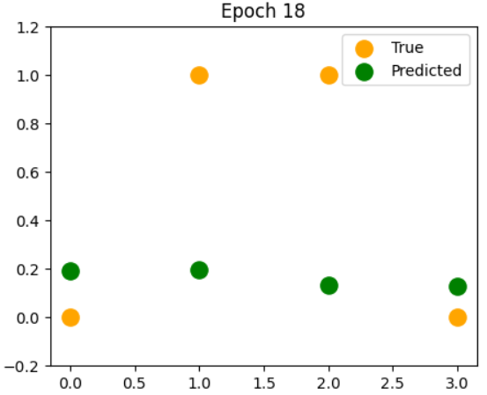

EPOCH 19
Hidden Input:
[[-0.02626751 -0.01892881 0.01992878 -0.09722856 -0.10864147]
[-0.27697777 1.55119579 0.79974151 -0.63987786 0.36746963]
[ 0.45888572 -0.1692063 0.6771868 1.3919839 -0.39281028]
[ 0.20817546 1.40091831 1.45699953 0.8493346 0.08330082]]
Hidden Output:
[[0.4934335 0.49526794 0.50498203 0.47571199 0.47286632]
[0.43119487 0.82508637 0.68991918 0.34527415 0.59084741]
[0.61274981 0.45779907 0.66311053 0.80090877 0.40304097]
[0.55185672 0.80232957 0.81107333 0.70042754 0.52081317]]
Output Input:
[[-1.38642494]
[-1.33465567]
[-1.80844006]
[-1.82953031]]
Predicted Output:
[[0.19997911]
[0.20839031]
[0.14082676]
[0.13829424]]
LOSS: 0.3559853739797418
ACCURACY: 0.5
Updated Weights Input-Hidden:
[[ 0.48449018 -0.1509209 0.65815087 1.48690367 -0.2874655 ]
[-0.25161034 1.56967422 0.7809089 -0.54723632 0.47178 ]]
Updated Weights Hidden-Output:
[[-0.31248958]
[-0.26482798]
[ 0.44432482]
[-1.74985555]
[-1.56793503]]

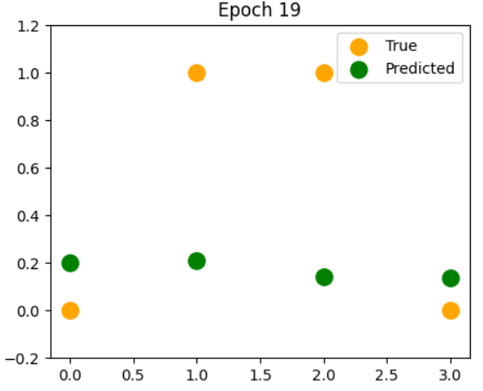

EPOCH 20
Hidden Input:
[[-0.02770437 -0.01987322 0.02168174 -0.10332856 -0.11566003]
[-0.27931472 1.54980101 0.80259064 -0.65056488 0.35611997]
[ 0.45678581 -0.17079412 0.67983261 1.38357511 -0.40312553]
[ 0.20517546 1.3988801 1.46074151 0.83633879 0.06865447]]
Hidden Output:
[[0.49307435 0.49503186 0.50542022 0.47419082 0.47111718]
[0.43062179 0.82488499 0.69052837 0.34286225 0.58810086]
[0.6122514 0.45740496 0.66370134 0.79956456 0.40056163]
[0.55111468 0.80200612 0.81164606 0.69769356 0.51715688]]
Output Input:
[[-1.33521624]
[-1.27442345]
[-1.75089547]
[-1.76186963]]
Predicted Output:
[[0.20829785]
[0.21850097]
[0.14793429]
[0.14655634]]
LOSS: 0.3504058657010755
ACCURACY: 0.5
Updated Weights Input-Hidden:
[[ 0.48383512 -0.15154974 0.65909151 1.48456828 -0.2907913 ]
[-0.25249109 1.56924082 0.78205149 -0.55182102 0.46742918]]
Updated Weights Hidden-Output:
[[-0.30287128]
[-0.25207806]
[ 0.45744412]
[-1.7396004 ]
[-1.55835114]]
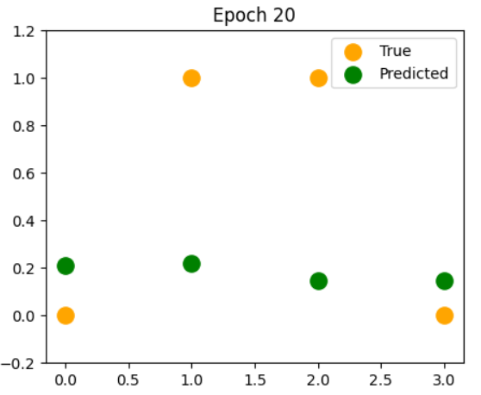

EPOCH 21
Hidden Input:
[[-0.02911358 -0.02078514 0.02350796 -0.10942649 -0.12271237]
[-0.28160467 1.54845567 0.80555946 -0.66124751 0.34471681]
[ 0.45472154 -0.17233488 0.68259947 1.37514179 -0.41350367]
[ 0.20223046 1.39690594 1.46465097 0.82332077 0.05392551]]
Hidden Output:
[[0.49272212 0.4948039 0.50587672 0.47267064 0.46936035]
[0.43006041 0.82469057 0.69116244 0.34045943 0.58533584]
[0.61176124 0.45702259 0.66431863 0.79820962 0.39807231]
[0.55038601 0.80169245 0.812243 0.69494079 0.51347811]]
Output Input:
[[-1.28358117]
[-1.21373793]
[-1.69284848]
[-1.69367254]]
Predicted Output:
[[0.21694125]
[0.22904034]
[0.15540161]
[0.15529348]]
LOSS: 0.34472620500929746
ACCURACY: 0.5
Updated Weights Input-Hidden:
[[ 0.48319037 -0.15216154 0.66008023 1.48221339 -0.29413755]
[-0.25334904 1.56882631 0.78323868 -0.55638755 0.463073 ]]
Updated Weights Hidden-Output:
[[-0.29317193]
[-0.23924131]
[ 0.47069874]
[-1.72927455]
[-1.54874549]]
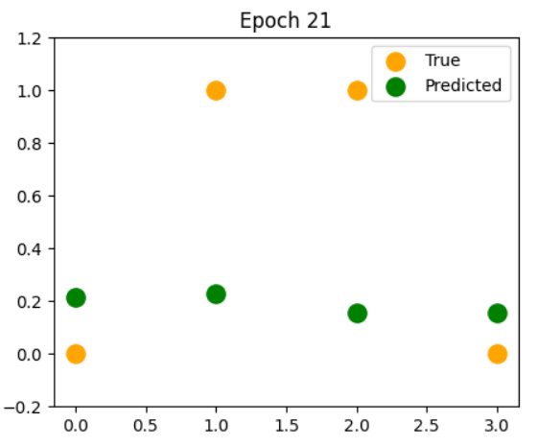

EPOCH 22
Hidden Input:
[[-0.03048998 -0.02166087 0.02540458 -0.1155012 -0.12977747]
[-0.28383901 1.54716545 0.80864326 -0.67188875 0.33329553]
[ 0.45270039 -0.17382241 0.68548481 1.36671219 -0.42391503]
[ 0.19935135 1.3950039 1.46872349 0.81032464 0.03915797]]
Hidden Output:
[[0.4923781 0.494585 0.5063508 0.47115676 0.46760109]
[0.42951284 0.82450396 0.69182032 0.33807405 0.58256101]
[0.61128108 0.45665348 0.66496175 0.79684844 0.3955803 ]
[0.54967344 0.80138989 0.81286329 0.69217868 0.50978824]]
Output Input:
[[-1.23166029]
[-1.15276706]
[-1.63445501]
[-1.62512779]]
Predicted Output:
[[0.22589097]
[0.23998403]
[0.16322098]
[0.1644989 ]]
LOSS: 0.3389775032772889
ACCURACY: 0.5
Updated Weights Input-Hidden:
[[ 0.48255828 -0.15275387 0.66111683 1.47984709 -0.29749457]
[-0.25418077 1.56843253 0.78446794 -0.56091883 0.45872718]]
Updated Weights Hidden-Output:
[[-0.28341947]
[-0.22635847]
[ 0.48405059]
[-1.71890719]
[-1.53914862]]
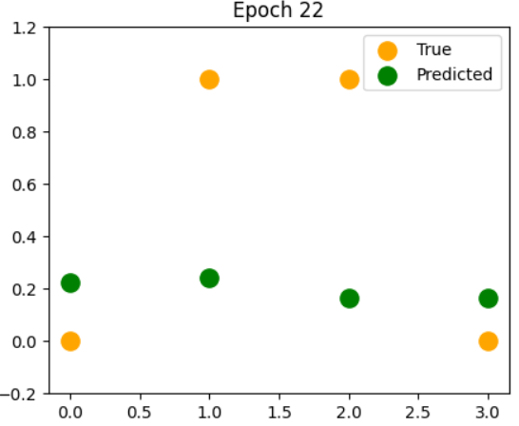

EPOCH 23
Hidden Input:
[[-0.03182842 -0.02249684 0.02736757 -0.12152981 -0.13683238]
[-0.28600919 1.54593569 0.8118355 -0.68244864 0.3218948 ]
[ 0.45072987 -0.17525071 0.6884844 1.35831728 -0.43432694]
[ 0.1965491 1.39318182 1.47295234 0.79739845 0.02440023]]
Hidden Output:
[[0.49204357 0.49437603 0.50684147 0.46965489 0.46584518]
[0.42898116 0.82432594 0.6925005 0.33571501 0.57978596]
[0.61081275 0.45629911 0.66562969 0.79548608 0.39309357]
[0.5489797 0.80109972 0.81350571 0.68941771 0.50609976]]
Output Input:
[[-1.17961015]
[-1.09169721]
[-1.57588912]
[-1.55644513]]
Predicted Output:
[[0.2351223 ]
[0.25129882]
[0.17137847]
[0.17415734]]
LOSS: 0.33319509381450463
ACCURACY: 0.5
Updated Weights Input-Hidden:
[[ 0.48194126 -0.15332433 0.66220059 1.4774784 -0.30085171]
[-0.25498296 1.56806112 0.78573597 -0.56539681 0.45440853]]
Updated Weights Hidden-Output:
[[-0.27364477]
[-0.21347425]
[ 0.49745726]
[-1.70853033]
[-1.52959331]]

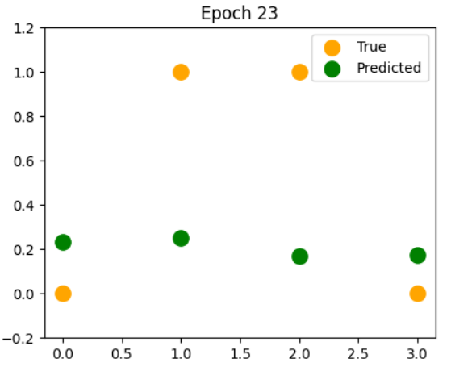

EPOCH 24
Hidden Input:
[[-0.03312389 -0.0232898 0.02939172 -0.12748802 -0.1438524 ]
[-0.28810685 1.54477132 0.81512769 -0.69288483 0.31055613]
[ 0.44881737 -0.17661414 0.69159231 1.34999038 -0.4447041 ]
[ 0.19383441 1.39144699 1.47732829 0.78459357 0.00970442]]
Hidden Output:
[[0.49171979 0.49417781 0.5073474 0.46817109 0.46409879]
[0.42846741 0.82415726 0.69320111 0.33339164 0.577021 ]
[0.61035802 0.45596088 0.66632105 0.79412806 0.39062065]
[0.54830745 0.80082315 0.81416869 0.68666929 0.50242609]]
Output Input:
[[-1.12760162]
[-1.03073105]
[-1.51734111]
[-1.48785291]]
Predicted Output:
[[0.24460398]
[0.2629424 ]
[0.17985339]
[0.18424421]]
LOSS: 0.3274178522935876
ACCURACY: 0.5
Updated Weights Input-Hidden:
[[ 0.48134163 -0.15387067 0.66333022 1.47511715 -0.30419755]
[-0.2557525 1.56771349 0.78703879 -0.56980277 0.45013469]]
Updated Weights Hidden-Output:
[[-0.26388118]
[-0.20063665]
[ 0.51087261]
[-1.69817837]
[-1.52011414]]
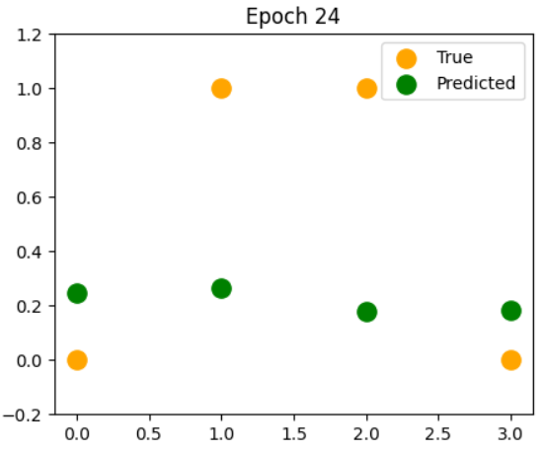

EPOCH 25
Hidden Input:
[[-0.03437162 -0.02403688 0.03147062 -0.13335051 -0.15081159]
[-0.29012412 1.54367661 0.81850941 -0.70315328 0.2993231 ]
[ 0.44697002 -0.17790755 0.69480084 1.34176664 -0.45500915]
[ 0.19121751 1.38980594 1.48183963 0.77196387 -0.00487446]]
Hidden Output:
[[0.49140794 0.49399107 0.50786701 0.46671169 0.4623684 ]
[0.42797348 0.82399856 0.69391984 0.33111348 0.57427703]
[0.60991859 0.45564005 0.66703404 0.79278031 0.38817046]
[0.54765925 0.80056126 0.81485028 0.68394557 0.49878139]]
Output Input:
[[-1.07581734]
[-0.97008443]
[-1.45901472]
[-1.41959464]]
Predicted Output:
[[0.25429836]
[0.27486367]
[0.18861807]
[0.19472514]]
LOSS: 0.32168721738004374
ACCURACY: 0.5
Updated Weights Input-Hidden:
[[ 0.48076164 -0.1543908 0.66450382 1.47277384 -0.30752011]
[-0.25648658 1.56739076 0.78837169 -0.57411777 0.44592375]]
Updated Weights Hidden-Output:
[[-0.25416398]
[-0.18789615]
[ 0.52424753]
[-1.68788745]
[-1.51074669]]
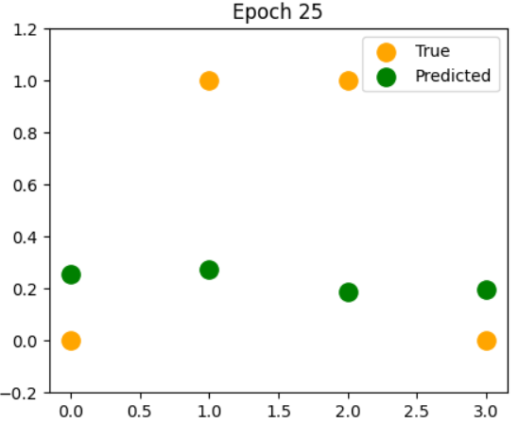

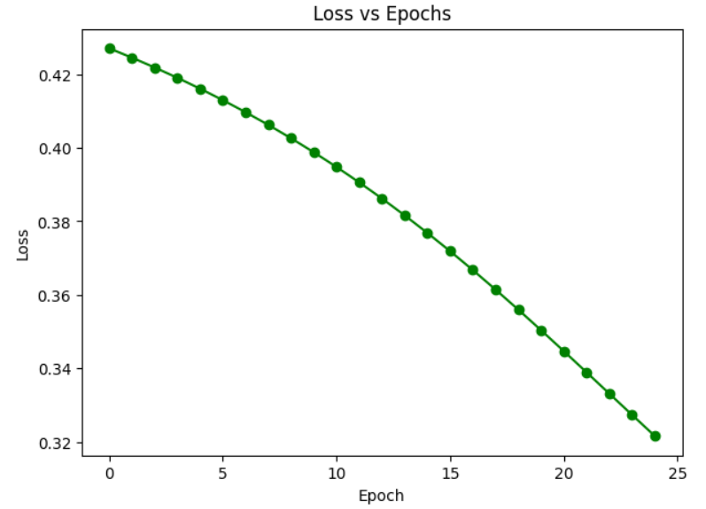
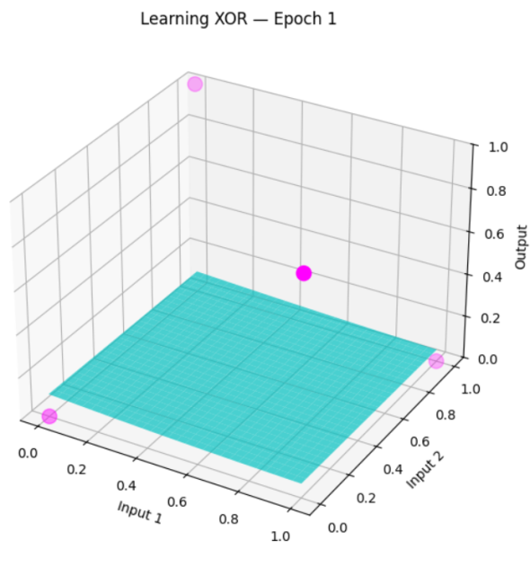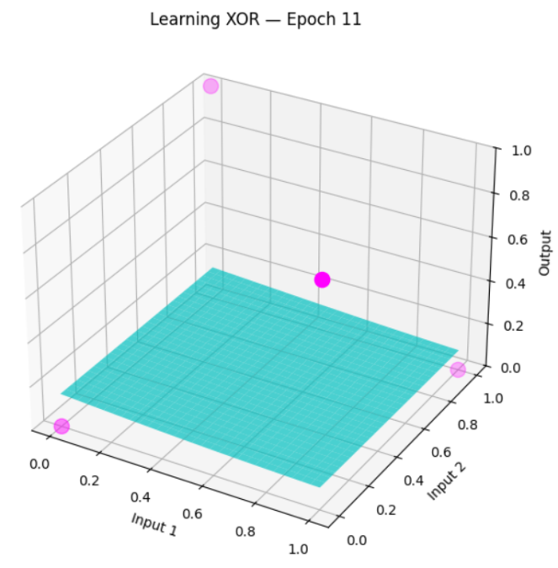
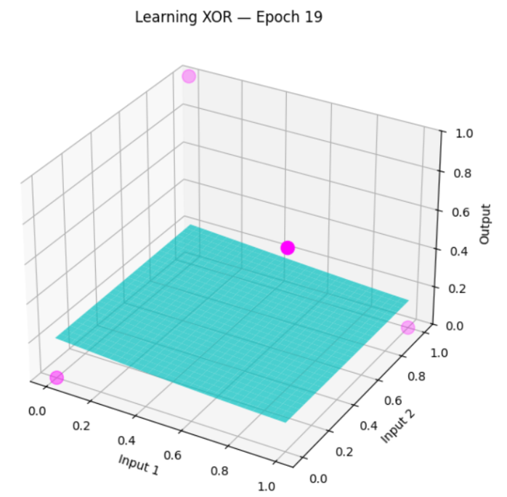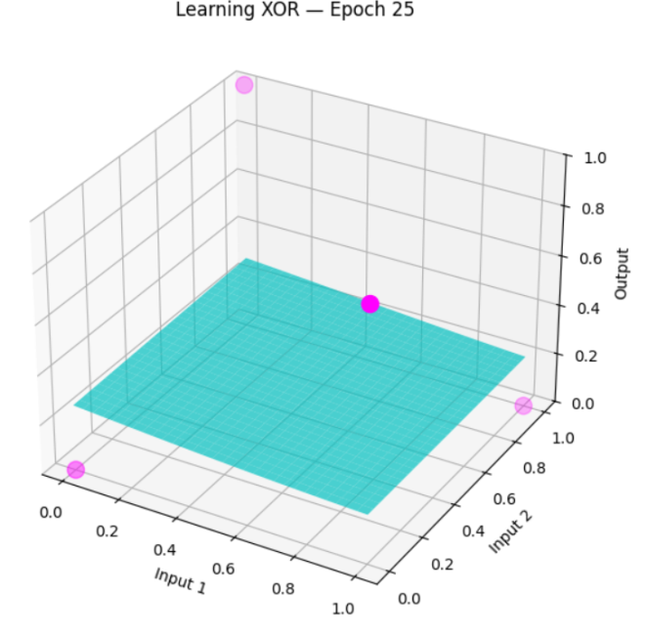
#comments :
What I learned from this code:

From this code I have learned how the neural network work and I also try to understand about forwarded propagation, backward propagation and loss calculation and see how the weight of my code is update during training I also learn XOR problem can't be solve with simple line so I use there hidden layer I also learn use of numpy to calculate my mathematics and matplotlib for graph and 3 D visualization

Problems I faced:

First when I run my code not give me the correct output and accuracy was also low and I Analysis loss was not decreasing and I also got confused with how the matrix multiplication shape and creating that 3 D animation is very differently for me

